Here is what is complete in Admin Console:
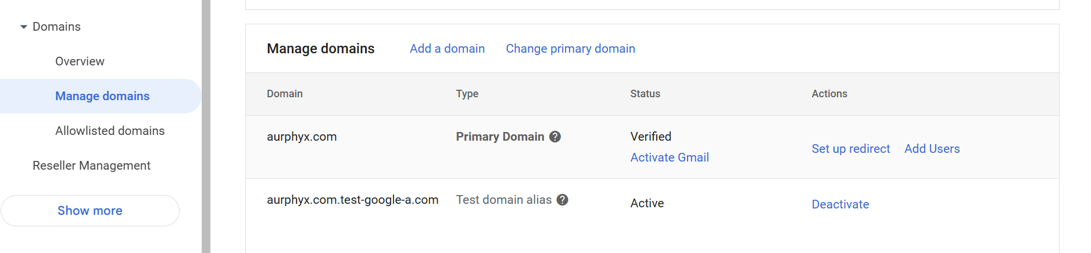
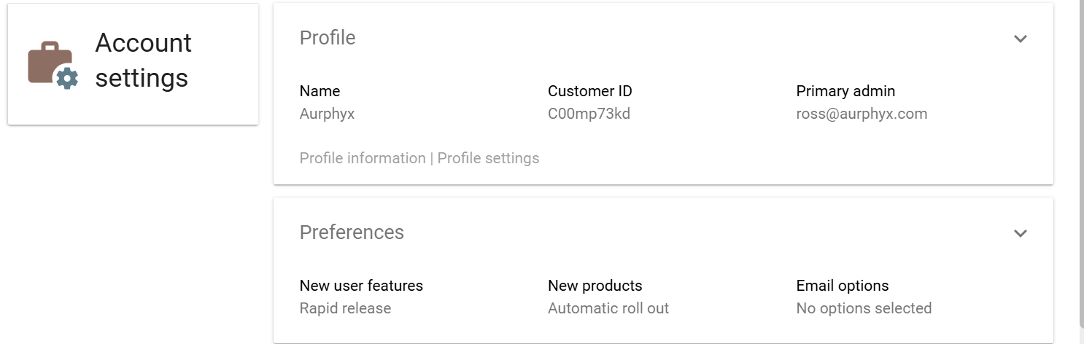
So I need help setting up everything else.

